AI-Augmented Backend Development Project : BlogNestAPI

TITLE : BlogNestAPI

Project Description

In a Single Paragraph
BlogNestAPI is an AI-Augmented backend Web Application developed using the (MongoDB, Express.js,Node.js) integrated with Artificial Intelligence capabilities such as Large Language Models (LLMs), Semantic Search, Vector Search, and Intelligent Recommendations. The system enables users to interact with data through natural language, receive AI-generated insights, perform semantic searches, upload and analyze documents, and automate decision-making processes. By combining traditional backend development with modern AI technologies, the platform delivers an intelligent, scalable, and user-friendly experience that improves productivity, accessibility, and operational efficiency.

Scenario
BlogNestAPI is designed to simplify blog content management and content creation for bloggers, readers, and developers. Traditional blog systems often require manual content preparation, keyword-based searching, and separate tools for organization and discovery.
The project combines a RESTful backend with AI services so users can manage blog content and use intelligent features from a single platform.
Problem: Users may spend significant time creating, organizing, searching, summarizing, and discovering blog content. Traditional keyword search may also miss content that is relevant by meaning rather than exact words.
- Need for AI: AI can reduce repetitive work, understand natural-language requests, generate and summarize content, and improve search and recommendations using semantic understanding.
- Proposed Solution: BlogNestAPI combines Node.js, Express.js, MongoDB, and AI capabilities to provide the following features:
  - AI Chatbot
  - Content Generation
  - Question Answering
  - Semantic Search
  - Vector Search
  - Intelligent Recommendations
  - Document Analysis
  - AI-powered Insights

Structure :
Problem:
Bloggers, content creators, and readers often face difficulties in creating, organizing, searching, and managing blog content. Traditional blog platforms may require manual content creation and rely mainly on keyword-based search, making it difficult to find relevant information and manage large amounts of content efficiently.
AI Solution:
AI BlogNestAPI solves these problems by combining a RESTful backend with Artificial Intelligence capabilities. It provides AI chatbot, content generation, question answering, semantic search, vector search, intelligent recommendations, document analysis, text summarization, and AI-powered insights to make blog management and content discovery easier.
Impact:
The application benefits bloggers, readers, content creators, and developers by reducing manual effort and improving productivity. Users can create and manage content more efficiently, find relevant information through semantic search, receive intelligent recommendations, and interact with content using natural language. This provides a more organized, scalable, and user-friendly blogging experience.

System Requirements :
The following software and hardware prerequisites support development, testing, deployment, and use of the BlogNestAPI AI-Augmented Backend Application.

1. Software Requirements

Operating System
- Windows 10/11
- macOS
- Linux

Node.js (v18 or above)
Provides a runtime environment for frontend and backend development.

npm (v9 or above)
Package manager used for dependency installation.

Express.js
Backend framework used for API development.

MongoDB Community Server / MongoDB Atlas
NoSQL database used to store:
- User Information
- Chat History
- Documents
- Embeddings
- AI Interactions
- Application Data

MongoDB Atlas Search
Provides full-text search functionality.

MongoDB Atlas Vector Search
Enables semantic search using vector embeddings.

AI Service Provider
- OpenAI API
- Gemini API
- Claude API
- Azure OpenAI (Optional) …etc

LangChain / AI SDK
Used for orchestration of AI workflows.

Browser
- Google Chrome
- Brave Browser

Postman
API Testing

Visual Studio Code
Development Environment

Git & GitHub
Version Control

2. Hardware Requirements

Processor
Intel Core i5 (8th Gen+) / AMD Ryzen 5+

RAM
Minimum 8 GB
Recommended 16 GB

Storage
Minimum 5 GB Free Space

Internet Connection
Required for AI API communication

Display
1366 × 768 or above

Project Architecture

Technical Architecture :
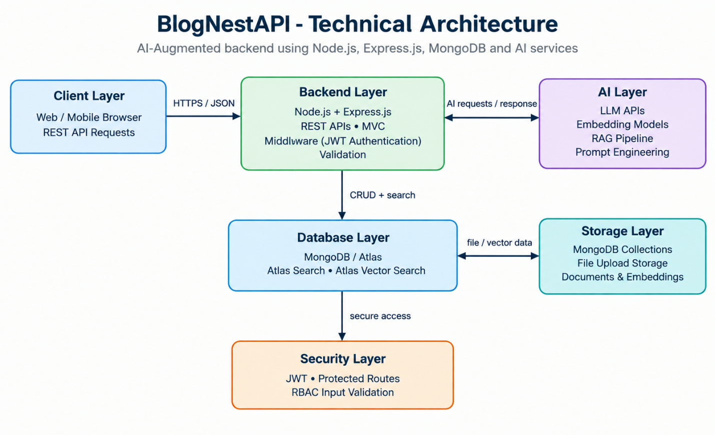

Backend Layer
- Node.js
- Express.js
- JWT Authentication
- REST APIs

Database Layer
- MongoDB
- Atlas Search
- Atlas Vector Search

AI Layer
- LLM APIs
- Embedding Models
- RAG Pipeline
- Prompt Engineering

Storage Layer
- MongoDB Collections
- File Upload Storage

Security Layer
- JWT Authentication
- Protected Routes
- Input Validation
- Role-Based Access Control

ER Diagram
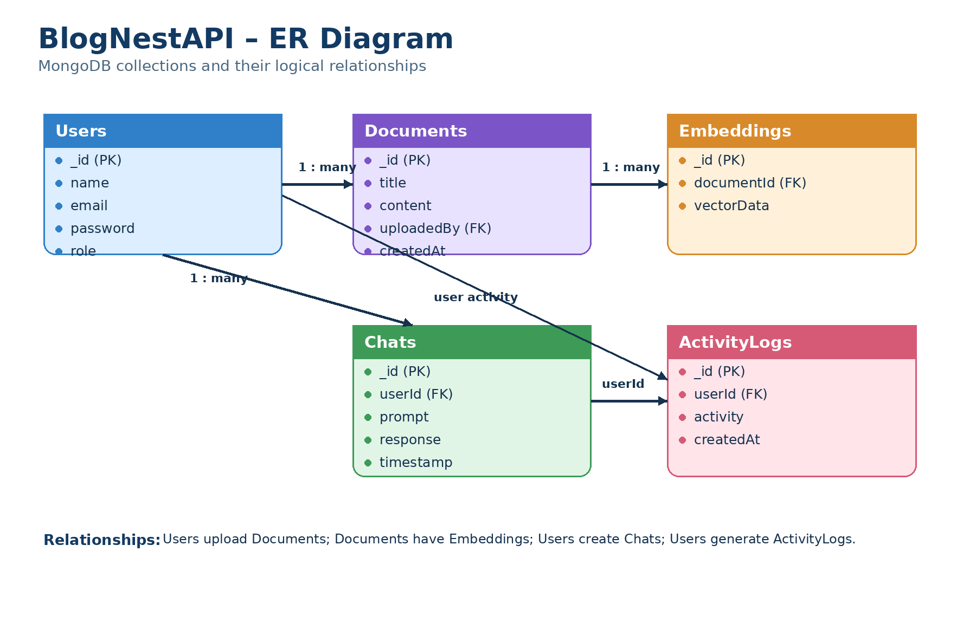

Collections

Users
- _id
- name
- email
- password
- role

Documents
- _id
- title
- content
- uploadedBy
- createdAt

Embeddings
- _id
- documentId
- vectorData

Chats
- _id
- userId
- prompt
- response
- timestamp

ActivityLogs
- _id
- userId
- activity
- createdAt

ER Diagram Explanation
Users can upload documents and interact with AI features. Uploaded documents are processed into vector embeddings and stored in MongoDB. Chat interactions and AI responses are logged for future reference and analytics. Activity logs maintain user actions across the system.

Features

Core Backend Features
- User Registration
- User Login
- JWT Authentication
- Protected Routes
- Middleware
- CRUD API
- File Upload
- Role-Based Access Control

AI Features
- AI Chat Assistant
- Semantic Search
- Vector Search
- Document Question Answering
- Text Summarization
- Content Generator
- RAG (Retrieval Augmented Generation)
- Intelligent Insights
- Natural Language Queries

Roles and Responsibilities

Admin
- Manage Users
- Manage Documents
- Monitor AI Usage
- View Analytics
- Configure System

User
- Register/Login
- Upload Documents
- Ask Questions
- Search Content
- View AI Recommendations
- Manage Personal Data

User Flow
- User Registration
- User Login
- JWT Authentication
- Dashboard Access
- Upload Documents
- Generate Embeddings
- Store Vectors in MongoDB
- User Query Submission
- Semantic Search Execution
- AI Response Generation
- Display Results
- Store Chat History

MVC Pattern
The backend follows the MVC (Model-View-Controller) architecture.

Model Layer
Responsible for:
- User Schema
- Chat Schema
- Document Schema
- Embedding Schema
- Activity Schema
Implemented using Mongoose.

Controller Layer
Responsible for:
- Authentication Logic
- AI API Integration
- Document Processing
- Embedding Generation
- Search Operations
- CRUD Operations

View Layer (Routes)
Defines REST API endpoints:

Authentication Routes
- Register
- Login
- Logout

AI Routes
- Chat
- Summarization
- Semantic Search

Document Routes
- Upload
- View
- Delete

User Routes
- Profile
- Dashboard

Advantages of MVC
- Separation of Concerns
- Better Maintainability
- Easy Scalability
- Reusable Components
- Team Collaboration
- Easier Testing

Project Setup and Configuration

Project Structure
Create Project Folder
Inside Project Folder:

Server Folder
Backend Application

Server Setup
mkdir server

cd server

npm init -y
Create:
server.js

models/
controllers/
routes/
middlewares/
config/
services/
utils/


Install Backend Packages
npm install express mongoose cors dotenv bcryptjs jsonwebtoken

npm install openai

npm install multer

npm install nodemon --save-dev


Backend Development
Include:
- Authentication APIs
- JWT Implementation
- AI Service Integration
- Vector Search APIs
- CRUD APIs
- Document Upload APIs
- Chat APIs
Note:
Proper explanation must be provided for every AI API consumed, including:
- Purpose:
The AI API is used to provide intelligent functionality such as AI chat, content generation, summarization, question answering, semantic search, recommendations, and document analysis. It reduces manual work and enables users to interact with blog content using natural language.

- Request Structure:
The backend sends a request to the AI service containing the required user prompt, input text, document context, and relevant parameters. Authentication credentials such as an API key are provided securely through environment variables rather than being exposed in the application code.

- Response Structure:
The AI service returns the generated result to the BlogNestAPI backend. The backend processes the response and sends the required information to the client in a structured format.

- Cost Considerations:
AI API usage may involve costs based on factors such as number of requests, input/output tokens, model selection, embedding generation, and overall usage. BlogNestAPI should monitor API consumption and use appropriate models and request limits to control costs.

- Security Practices:
AI API keys must be stored securely in environment variables and must never be exposed in source code or client-side applications. BlogNestAPI should use JWT authentication, protected routes, input validation, role-based access control, secure API communication (HTTPS), rate limiting, and appropriate error handling. Sensitive user or document data should not be unnecessarily sent to external AI services.

Database Development
Include:
- MongoDB Collections
- Relationships
- Atlas Search Index
- Vector Search Index
- Sample Documents
Provide screenshots and explanation.

Project Execution

Step 1: Backend
cd server

npm install


Step 2: Configure Environment Variables
Create .env
PORT=8000

MONGO_URI=mongodb://localhost:27017/ai_augmented_db

JWT_SECRET=your_secret_key

OPENAI_API_KEY=your_api_key


Step 3: Run Backend
nodemon server.js
Backend URL:
http://localhost:8000


Output with Explanation
- API Testing:
Output: Successful API requests and JSON responses for BlogNestAPI endpoints.
Explanation: API testing verifies that authentication, CRUD, AI, document upload, chat, and search APIs work correctly and return the expected responses.

- LLM Integration:
Output: AI-generated content or responses returned from the LLM service.
Explanation: BlogNestAPI connects with an LLM to provide AI features such as content generation, summarization, question answering, and intelligent text processing.

- AI Chat Interface:
Output: A chat screen displaying the user's question and the AI-generated answer.
Explanation: Users can interact with BlogNestAPI using natural-language questions. The backend sends the request to the AI service and returns the generated response.

- Document Upload:
Output: A successfully uploaded document with its processing status.
Explanation: Users can upload documents through the API. The document can then be processed for AI analysis, embedding generation, and semantic search.

- Search Results:
Output: A list of relevant blog posts or document content for a user's search query.
Explanation: Vector/semantic search helps retrieve relevant content based on the meaning of the query rather than relying only on exact keyword matches.

- Recommendation Engine:
Output: A list of recommended blogs or related content.
Explanation: The recommendation feature helps users discover relevant blog content based on available content information and user interactions.

Demo Video Link
Add Demo Video Link

Source Code Drive Link
Add Code Link

Mandatory Functionalities
- MVC Architecture
- JWT Authentication
- Semantic Search
- MongoDB Atlas Search
- MongoDB Atlas Vector Search
- Prompt Engineering
- AI API Integration
- Role-Based Access Control

